**CLASSROOM**

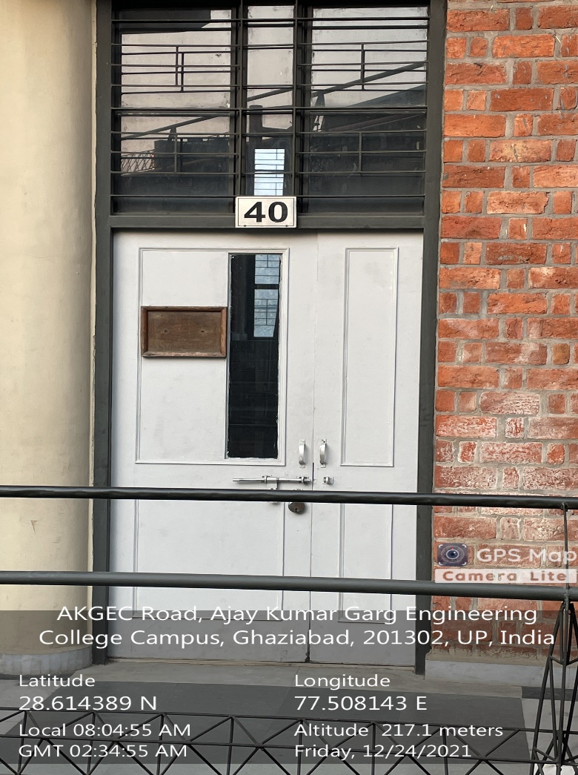

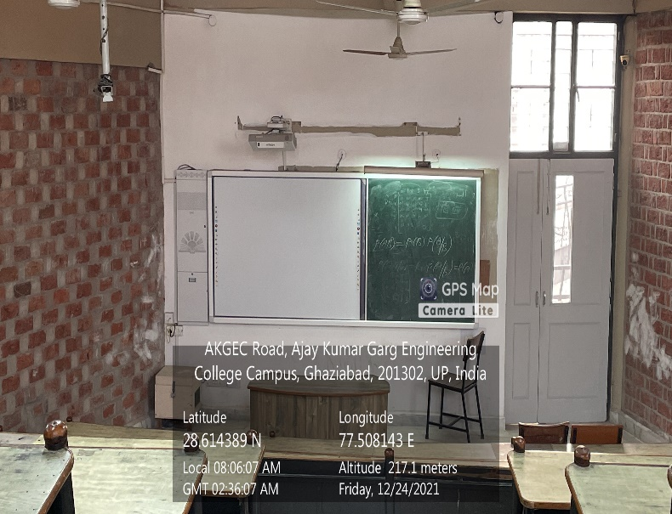

**ME Block, Second Floor, ME01**

**(Available Facilities: Green Board, Smart Board, Wi-Fi, Sound system)**

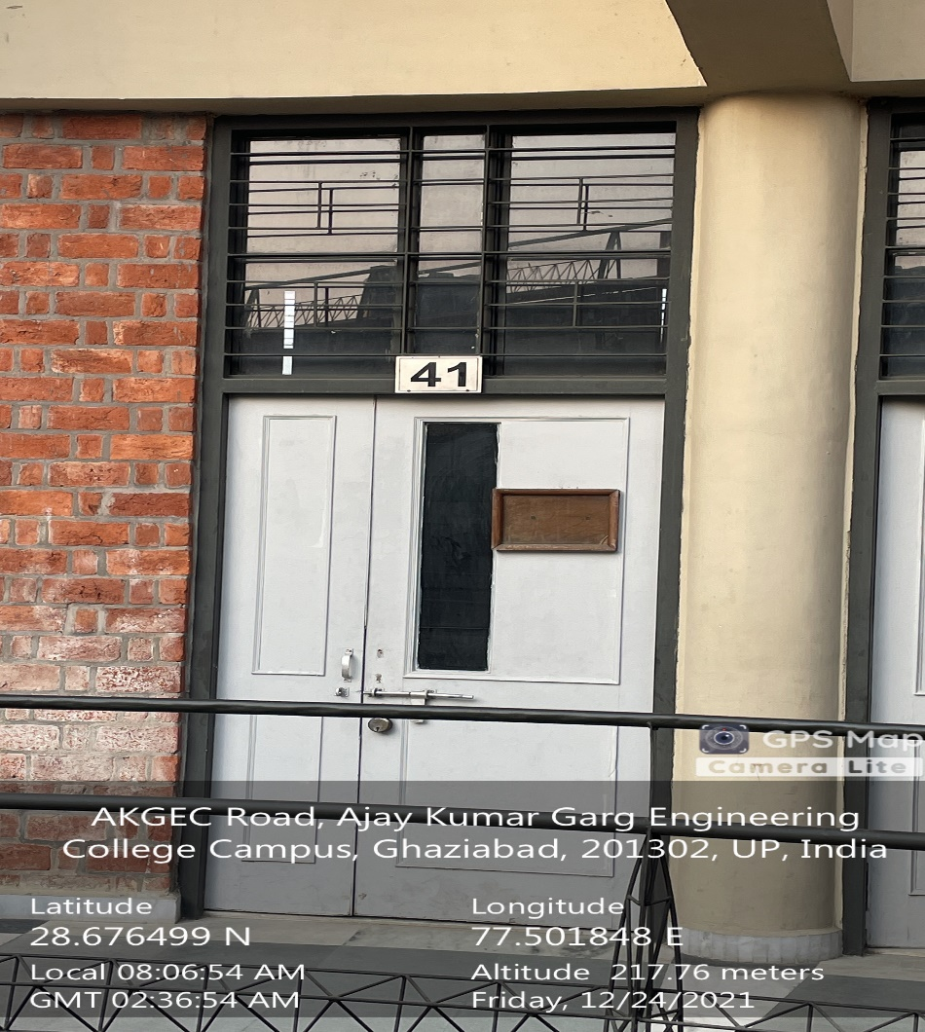

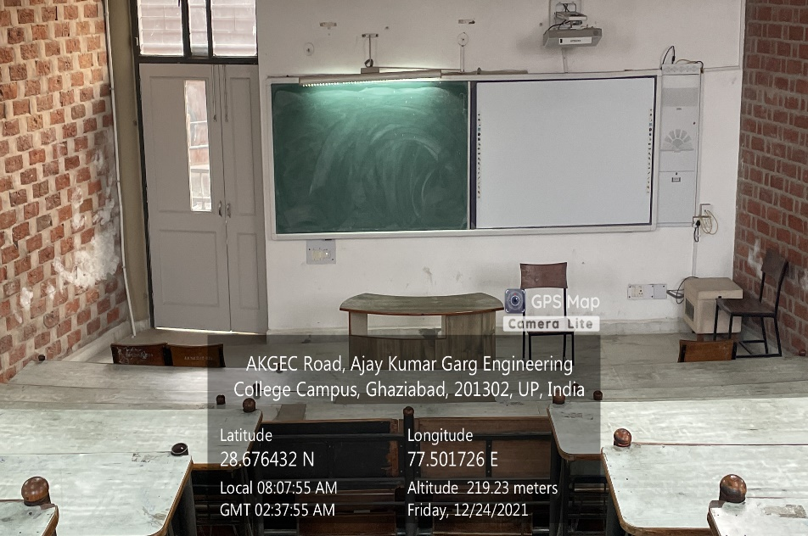

**ME Block, Second Floor, ME41**

**(Available Facilities: Green Board, Smart Board, Wi-Fi, Sound system)**

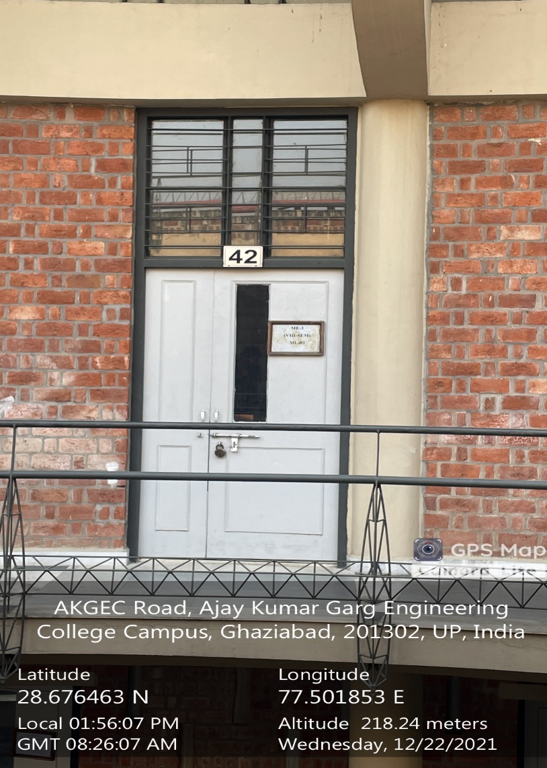

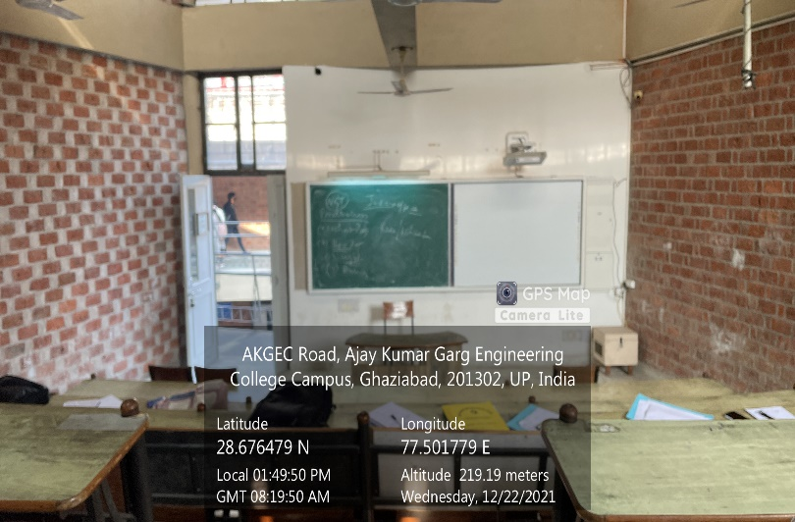

**ME Block, Second Floor, ME42**

**(Available Facilities: Green Board, Smart Board, Wi-Fi, Sound system)**

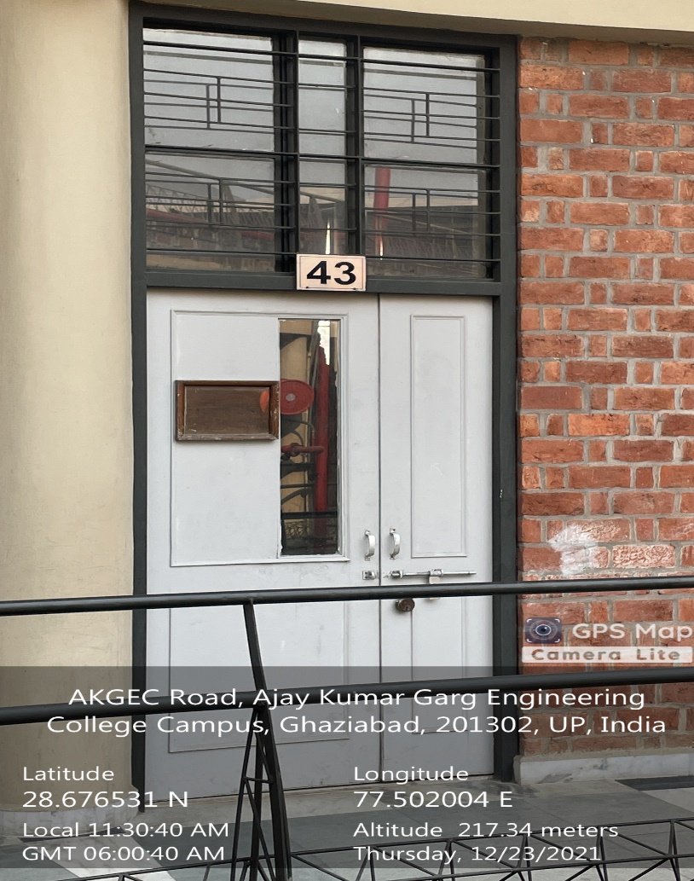

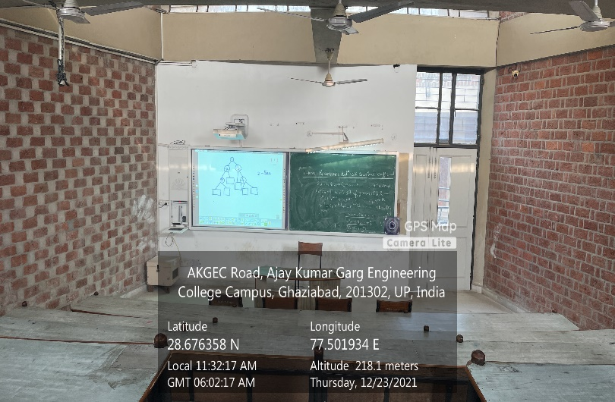

**ME Block, Second Floor, ME43**

**(Available Facilities: Green Board, Smart Board, Wi-Fi, Sound system)**

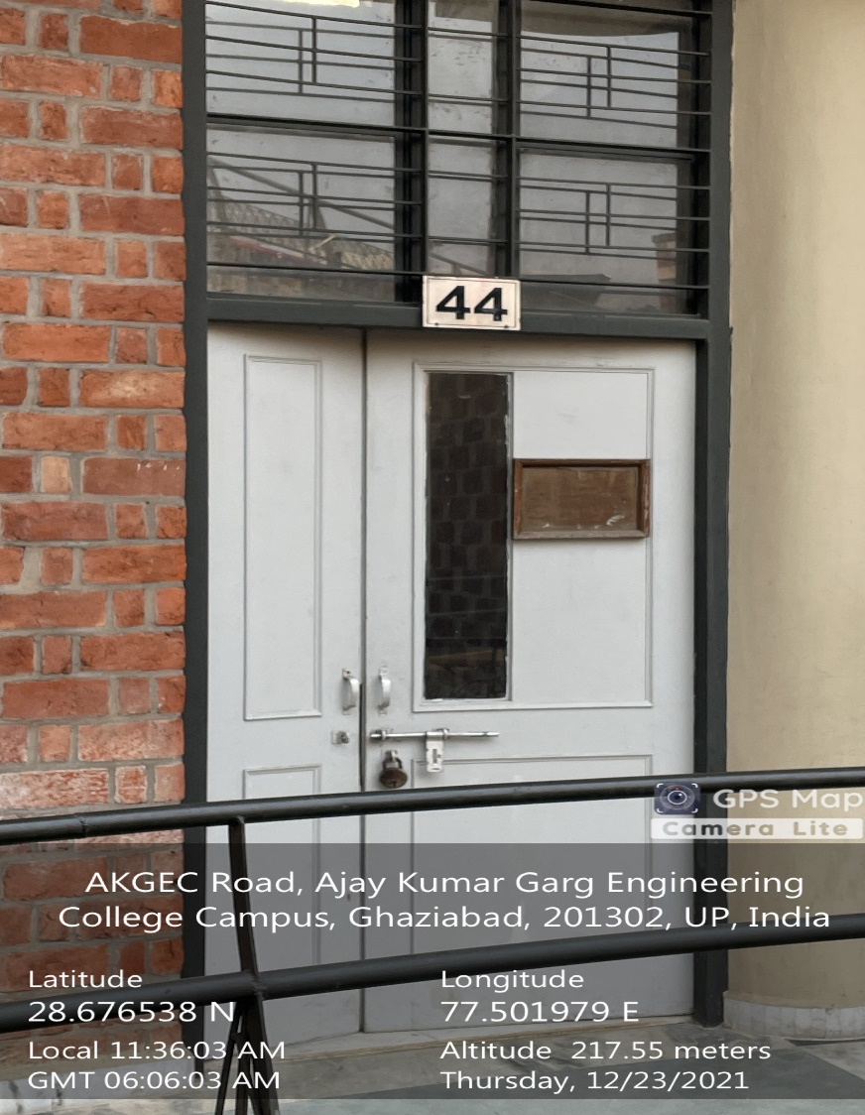

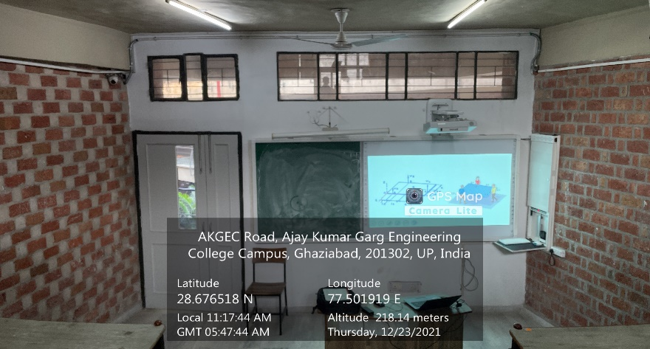

**ME Block, Second Floor, ME44**

**(Available Facilities: Green Board, Smart Board, Wi-Fi, Sound system)**

**TUTORIALS ROOM**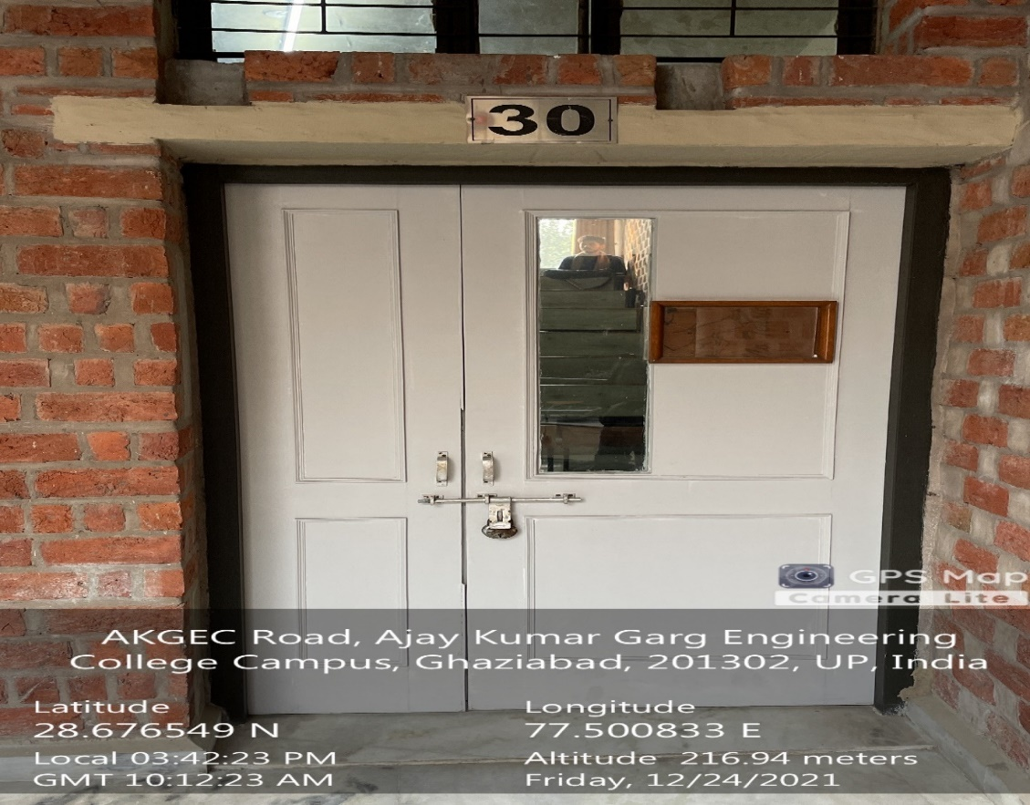

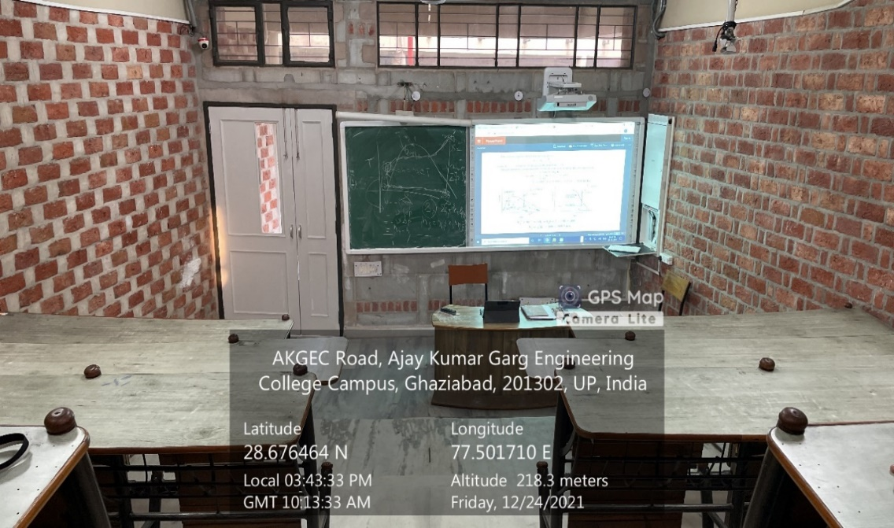

**ML -30**

**(ME Block, First Floor)**

**(Available Facilities: Green Board, Smart Board Wi-Fi, Sound System)**

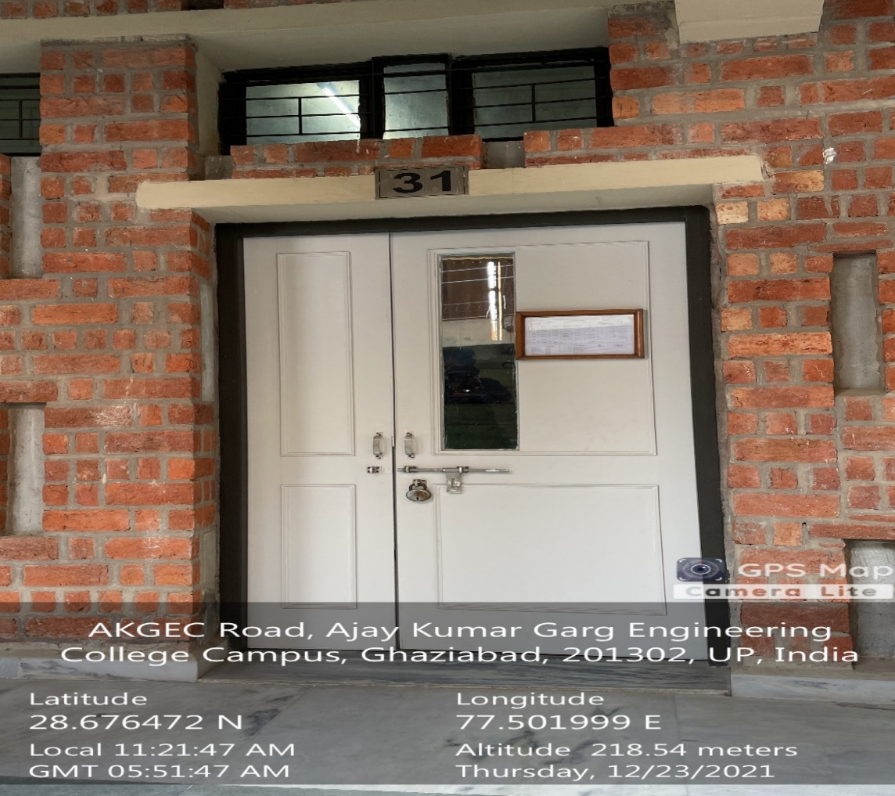

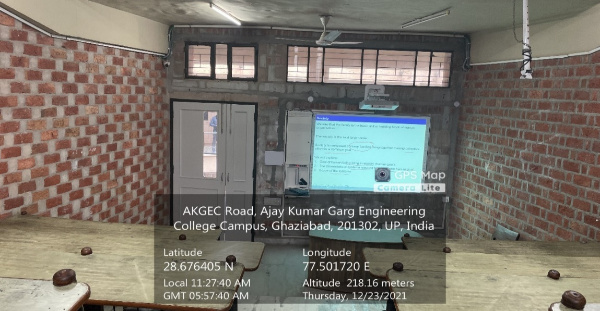

**ML -31**

**(ME Block, First Floor)**

**(Available Facilities: Green Board, Smart Board Wi-Fi, Sound System)**

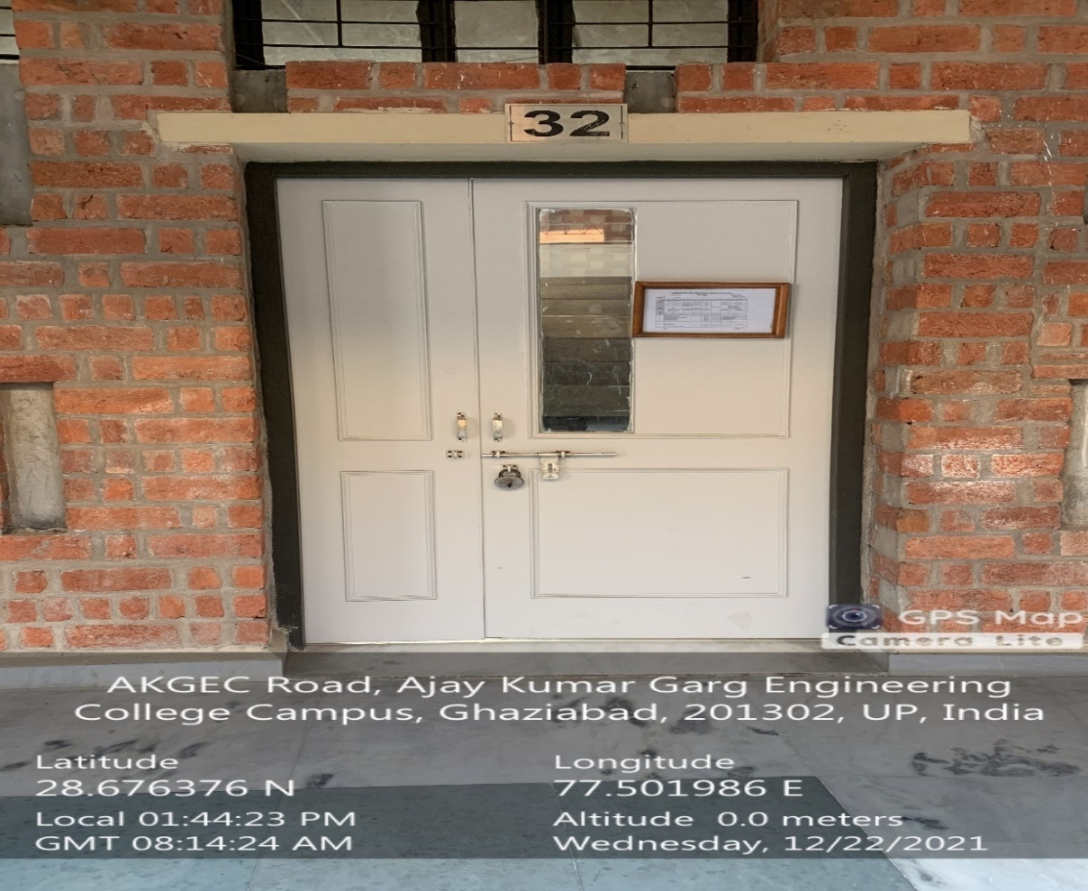

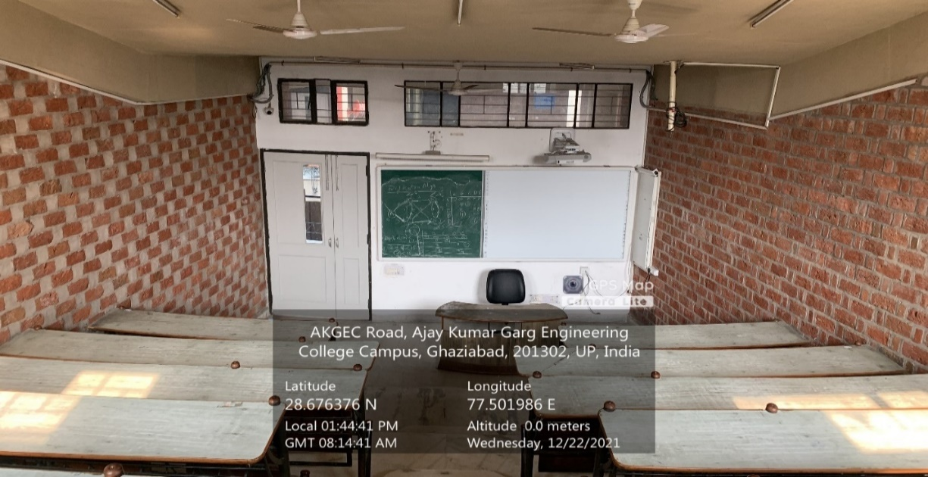

**ML -32**

**(ME Block, First Floor)**

**(Available Facilities: Green Board, Smart Board Wi-Fi, Sound System)**

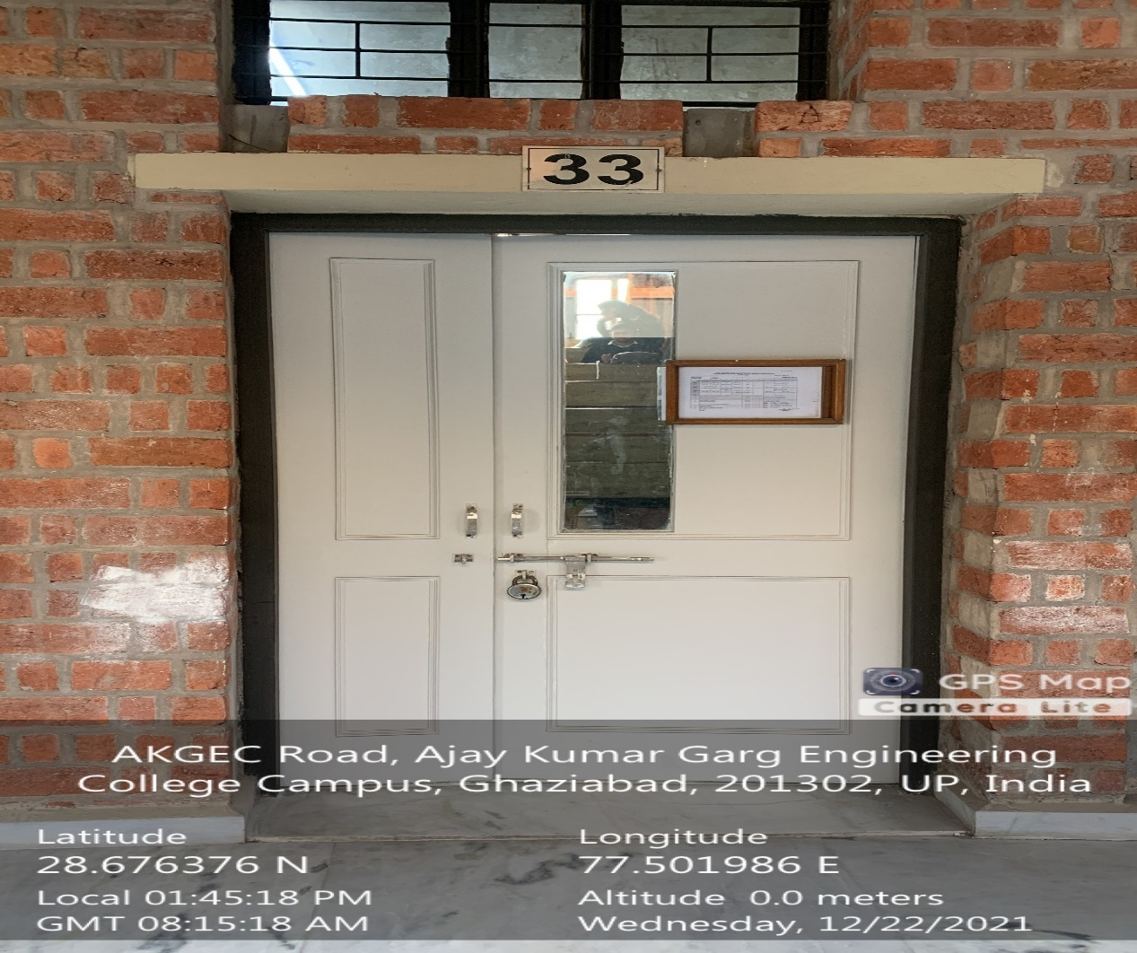

**‘**

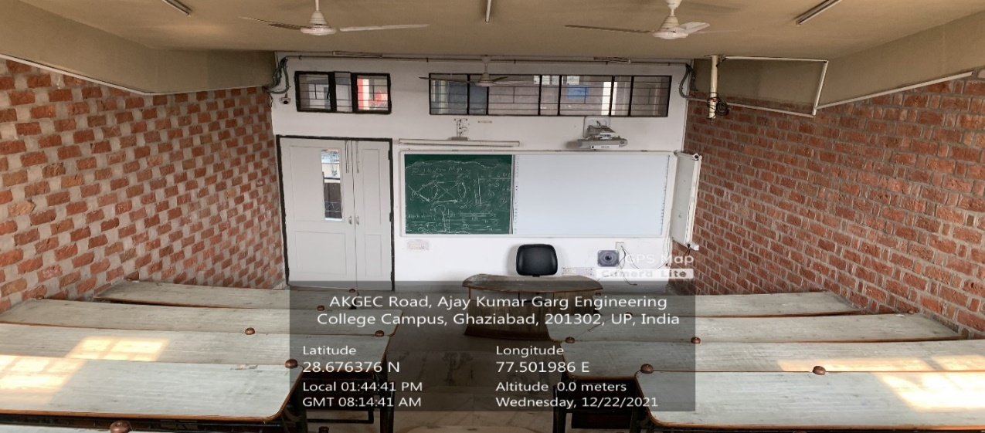

**ML -33**

**(ME Block, First Floor)**

**(Available Facilities: Green Board, Smart Board Wi-Fi, Sound System)**

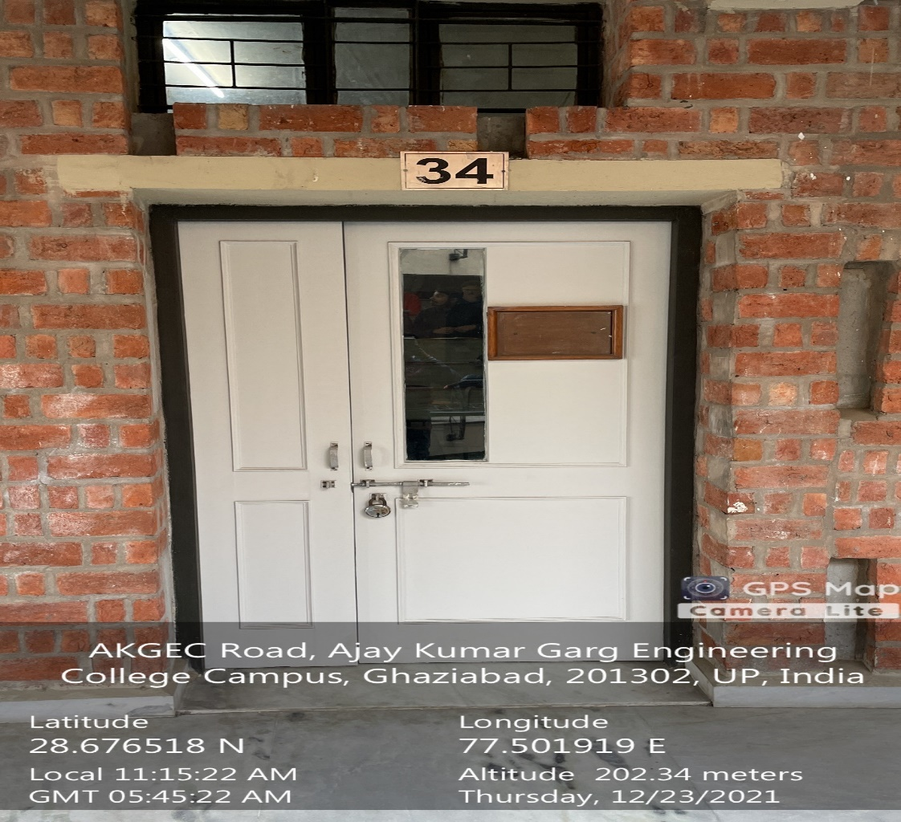

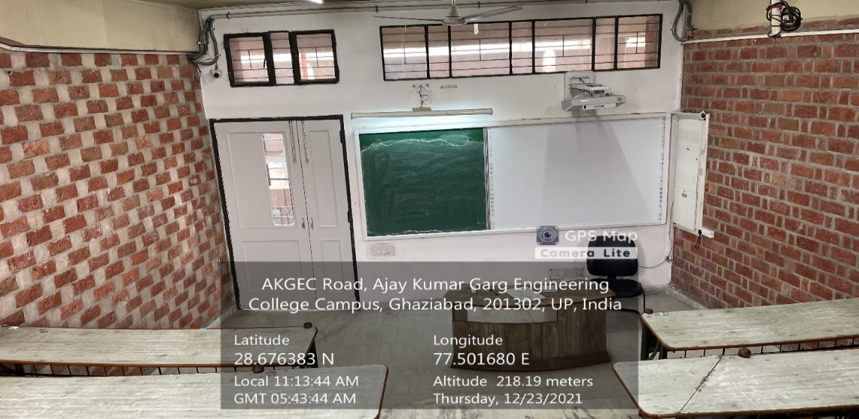

**ML -34**

**(ME Block, First Floor)**

**(Available Facilities: Green Board, Smart Board Wi-Fi, Sound System)**

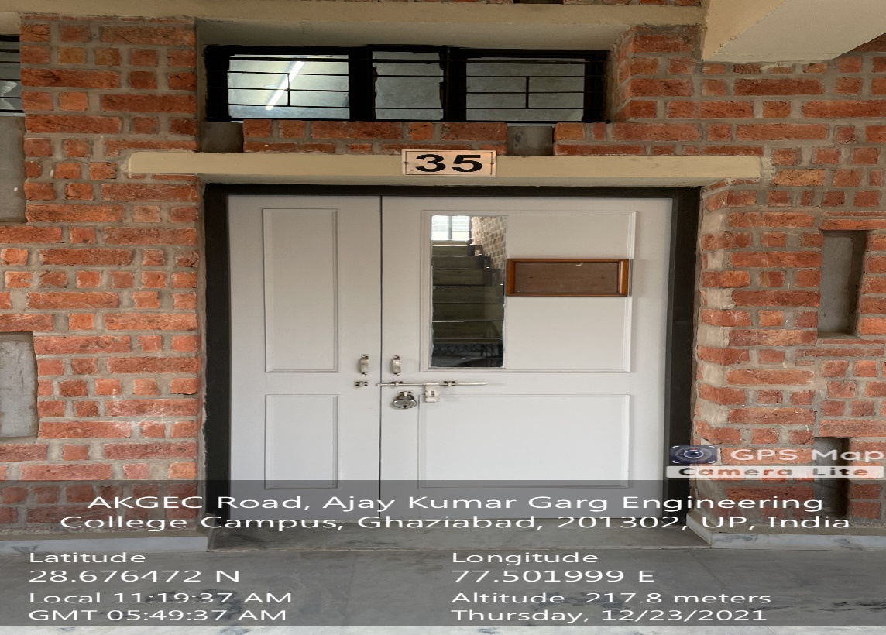

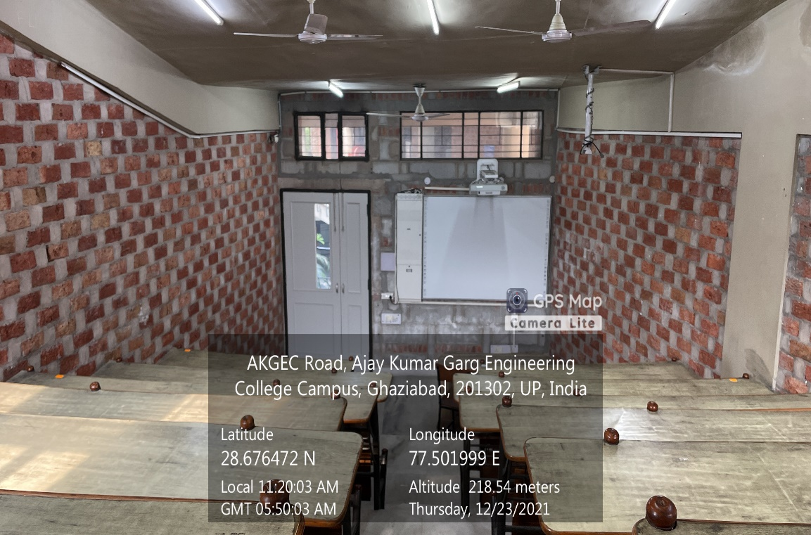

**ML -35**

**(ME Block, First Floor)**

**(Available Facilities: Green Board, Smart Board Wi-Fi, Sound System)**

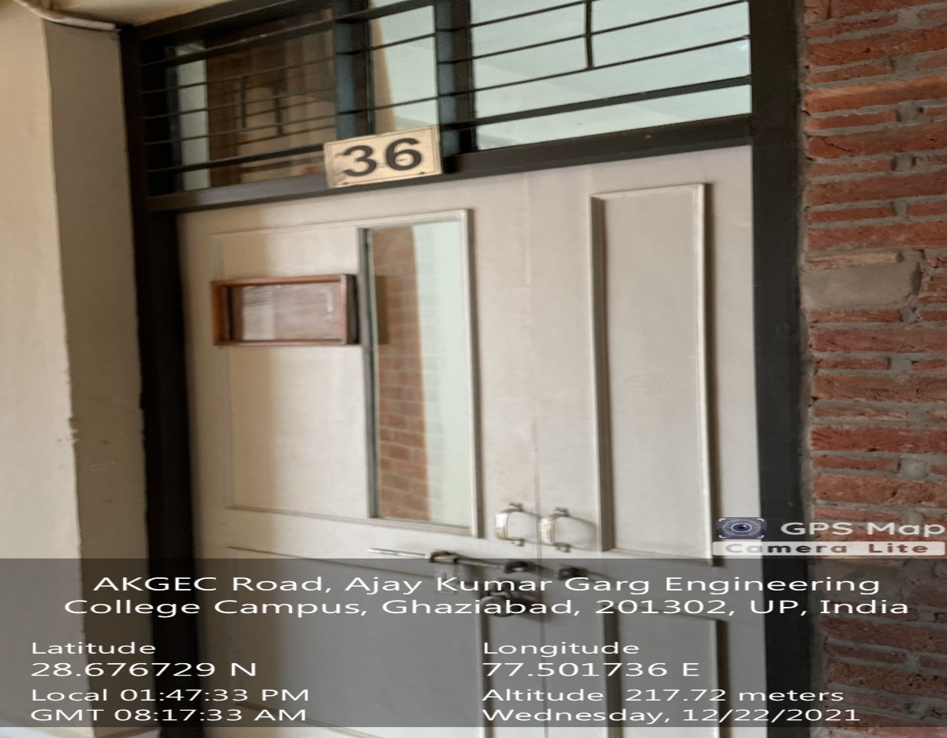

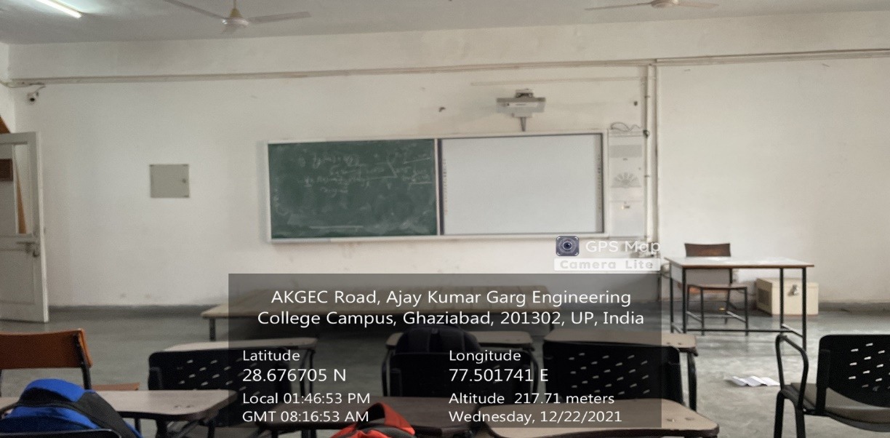

**TUTORIAL ROOM-2**

**(ME Block, First Floor)**

**(Available Facilities: Green Board, Smart Board Wi-Fi, Sound System)**